**Image Steganography embedded with Advance Encryption Standard (AES) securing with  
SHA-256**

**Yash Kumar Shukla, Vikas Singhal**

***Abstract*-** ***The proposed paper, works upon the idea of securing the classified information. This is achieved by using steganography which is an approach to hide classified information into some other file while maintaining its visual aids and secondly is cryptography which works upon textual data and transform it in a way that no one can comprehend it. The proposed method secures the weaker section which is the key in Advance Encryption Standard using hashing technique. The proposed work enhances the level of concealment of information from unauthorized access and for covert information exchange by encrypting the data and hiding it into a multimedia file known as image. The Secure Hash Algorithm 256 generates a hash key of 256 bits which is an unbreakable hashing technique after that the key is used in the process of encrypting the text with Advance Encryption Standard 256 which is an unbreakable encryption technique till this time and a cipher text is obtained. The cipher text is embedded into a target image using Least Significant Bit method which make changes in image that cannot be understand by naked eyes. The change in byte is 0.000002%. It ensures the visual quality of an image remains intact. The distortion or change in the image remains intermittent to human eyes. The major issue concerned for the government and security agencies such as were to exchange highly classified information in a secure and undetectable manner and abide the notion of hacker to comprehend any such information.***

***keywords*- *AES, Cryptography, Image steganography, LSB, SHA-256.***

1. **INTRODUCTION**

Data plays a vital role in merely each vertical or domains. Data provides the next level of insight into different verticals. The data has a versatile nature from personal to economic, governmental, national security, technology and so on. As we all know the data is the new oil so when storing, exchanging, and using data is done then arrives a high responsibility to maintain its confidentiality, integrity, availability of the data. The higher the confidential information, higher the security is needed. From several years data hiding has captured the minds of security agencies and researchers. Digital watermarking, filtering & masking and other steganographic techniques are used to hide confidential data into digital images. The cryptography converts the plain text into an incomprehensible cipher text whereas steganography conceals the traces of the data that could be ever existed. Steganography can be performed on any type of file text, video, audio, image, etc. any multimedia file can fall under this category [1].

When hackers want to access a system, they will aim for the weakest point, which is not the encryption, but the key. AES-256 is most secure encryption technique and till now there is no report of its cracking. But the key is the weakest point it order to secure that SHA-256 (Secure Hash Algorithm) will be used that will give a hash value. Hash is not ‘encryption’ because it can never be decrypted back to the initial text, it a one way street. This makes the system robust and patches the weakest link.

In this paper, our findings define that the system first the key will be entered and it will be hashed using Secure Hash Algorithm (SHA256) into a hash data or key which will be used in AES encryption where data get encrypted by the help of the key, by encryption a non-understandable cipher text is generated. And then this cipher text is embedded into the image using the LSB technique, and the change was into byte is 0.000002% which is an almost negligible and steganographic image or target image is generated containing secret data. And invisible to naked human eyes. Hence, a secured system is created where hashing, encoding as well as data hiding all are performed respectively. This enhances the level of security in the concealment of covert data exchange and information hiding.

1. **LITERATURE REVIEW**

The evolution in technology changes the life of mankind. As the technology eases mankind life, it also brings a need for additional security. Steganography is a mechanism of hiding confidential and sensitive information in images to have secure and untraceable communication between multiple individuals. Steganography ensures the exchange of data covertly using any digital communication medium, even the toughest condition of constant monitoring. There is a possibility of doing covert communication and exchange of data without being get noticed and no one can imagine the existence of a secret message inside an image. The embedding is done by weakening some of the traits of other media such as image, audio, video files which are also known as cover. The Final resultant has the same properties of cover media. The cover contains the crucial secret data in it. When a secret data is concealed inside a cover image, then it results in a stego image. This paper depicts the concept of steganography and proposed methodologies of steganographic images.

SHA-256 was developed by United States National Security Agency and then got recognized as well as published in the year 2001. SHA-256 is a cryptographic hash also known as the digest. It generates a unique 256-bit (32 bytes) code of a text. A hash is not an encryption technique so, it cannot be decrypted back to original data. It creates a fixed size of code from the source text. It is a single way cryptographic function. The hash version of the text is always gets compared only, which enhances security. It avoids transmitting password in original view format, even if the message gets intercepted between the medium or channel then also interceptor can never reach to the original password. The NIST (National institute of standard and technology) approves that it has never been compromised [2].

The Advance Encryption Standard (AES) is a cryptographic algorithm which is used to encrypt the textual data in an incomprehensible manner. And it is a most secured encryption standard till now where no signs of its breakage been reported till yet. It is a symmetric key algorithm, which means the same key is used for both encryption and decryption both. It uses a block cipher of sizes 128, 168, 192, 224 and 256 bits. It uses several ways in AES like XOR operation, substitution, permutation operation, rows and column shifting [3].

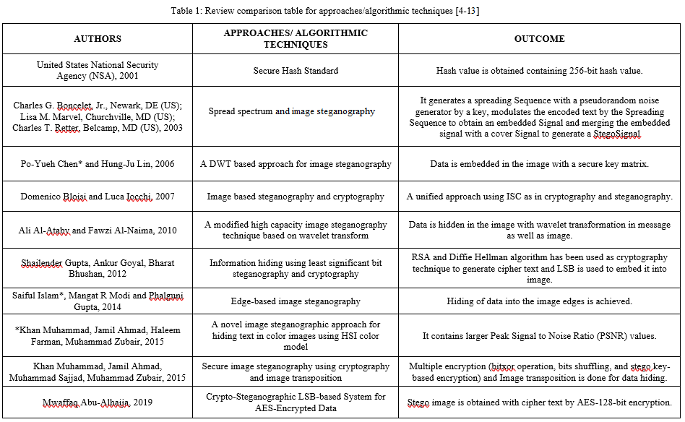Based on table 1 and after doing a detailed study, the proposed system technique has been chosen in order to have a robust system which in all aspect can shield the classified information and data within it.

1. **PROPOSED METHOD**

The Proposed methodology is to create a system which could be used for covert communication without any hint that some classified data is being exchanged via using image steganography and securing that data with cryptographic technique and even securing its vulnerable area that is key by using hashing.

1. *Least Significant Bit (LSB)*

The steganography technique embeds the data into the cover image or target image. This can be achieved by using various steganographic techniques. From a pool of steganographic techniques I will be accomplishing this task with the usage of LSB. This technique is implemented by making changes in the least significant bit (LSB) of a byte. LSB is a most promising steganographic technique which conceals the data in the image and no one can get a whisper that the image accommodates some crucial data within it. LSB provides the least change in the image which is far from persistent of a human naked eye. The change in a byte is 0.000002% which is almost negligible.

The least significant bit of the cover image bytes is changed by a bit of the classified data. LSB functions finest with 24-bit map (BMP) and PNG images in which each pixel is constituted of 3 bytes (red, green, blue) color   
  
respectively. LSB provides a method to store 3 bits of information in a single pixel, by making a change in one   
bit of each color component. Therefore, by using a 256*256 image, LSB can store 196608 bits (i.e. 24576 bytes) of data inside this cover image.

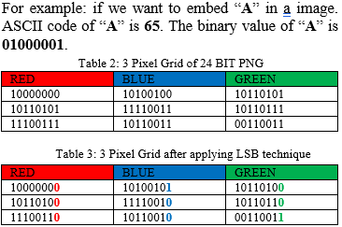

The table 2 contains the pixel gird of a image where each pixel flourishes some colors. Whereas In table 3 it can be clearly seen that the pixel grid of the cover image has been changed in order to embed data into it. And the change in each pixel is so nominal that it cannot be traced.

LSB makes use of lossless compression provided by PNG images. consecutive bytes of the image data are used to embed the information, initially from the first image pixel of each byte of the message in respective order. Consequently, LSB is the best way to hide data and communicate covertly but if any hacker thinks that the image contains confidential data, and he will try to extract the crucial data from it by use of steganalysis tools and if he is accomplishing his goal then our crucial data is in wrong hands. It orders to achieve a higher level of security this proposed system is created which add on advance level of security. This add on intricate multiple layers of imperishable security. The image constitutes of pixels that do not engage changes in the anatomy of the message in order to accomplish secure and imperceptible communication. A steganographic technique could embed an encrypted data in the cover image.

The proposed method acquires LSB technique in order to replace the least significant bits in the cover image which contains bits of the hidden message. In succession to enhance the security level of the proposed system, the covert data should be encrypted using AES encryption using a key which is generated using the SHA-256 hashing technique. The proposed system ensure the difference between an original image and a cover image which remains imperceptible to human senses, meanwhile sustaining the integrity of the confidential data without any loss.

1. *Secure Hash Algorithm (SHA-256)*

The Secure Hash Algorithm (SHA-256) is a part of family. The family of cryptographic hash functions which was published by the National Institute of Standards and Technology as a U.S. Federal Information Processing Standard. SHA-256 is patented in US patents 6829355. Hash is not ‘encryption’ because it can never be decrypted back to the initial text. It is of fixed length for any varying length of the source text. SHA-256 is achieved by the following steps like padding, append length, divide the input into 512bit blocks, add chaining variable, process block respectively. SHA-256 generates a unique 256-bit or we can say 32-byte of hash code. It does 64 rounds in order to reach to the final hash value.

The text length upto 264 bit i.e (2.3 exabyte) will also be transformed into a digest size of 256 bits (32 bytes). 16.80 cycles per byte on 64-bit processor x86 architecture. It has 64 iterations in one cycle. Which makes it more safe and secure.

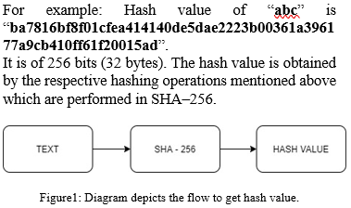

1. *Advance Encryption Standard (AES-256)*

AES is a symmetric key encryption technique, which use only one secret key to cipher(encrypt) and decipher(decrypt) data. Advanced Encryption Standard (AES) is only publicly accessible encryption technique authorized by the US National Security Agency (NSA) for securing top classified secret data. AES was earlier known as Rijndael after its two amazing developers known, Belgian cryptographers Vincent Rijmen and Joan Daemen. AES-256, uses a key length of 256 bits, it uses the largest bit length and is practically adamantine by brute force attack on the basis of current computing power, which makes it the strongest encryption standard. The AES encryption method first performs substitution of data using a substitution table; which is followed by shifting of data rows, then after that mixing of the columns takes place, and finally the last transformation with a simple exclusive (XOR) operation performed on each column using a different part of the encryption key

The following table shows that possible key combinations exponentially increase with the key length. And it also makes it hard to crack it.

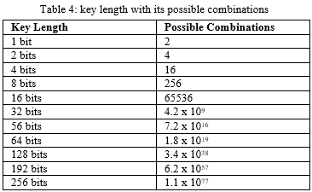

Figure 2: The Diagrammatic representation of AES-256

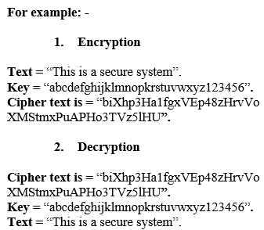

The length of the key is of 256 bit (32 byte) so, 14 rounds of AES encryption have been performed and as a result an incomprehensible cipher text is generated. Same key is used in decryption process also and as a result the text is obtained by running 14 rounds of decryption. All the process executes in a reverse order in a way to get the plain text.

1. **PHASES OF THE PROPOSED METHOD**

The first phase involves key generation which is done by using SHA-256 a hashing technique. Hash is not ‘encryption’ because it can never be decrypted back to the initial text. It is of fixed length for any varying length of the source text. SHA-256 is achieved by the following steps like padding, append length, divide the input into 512bit blocks, add chaining variable, process block respectively. SHA-256 generates a unique 256-bit or we can say 32-byte of hash code. It does 64 rounds in order to reach its final hash value. So, it is impermeable and till now there is no reporting of its breakage. By this, we generate the most secure key.

The second phase is converting the Plain text data into cipher text with the help of key. The AES encryption

performs several transformations on data. The initial step is to put the data into an array, after which the cipher transformations are repeated over a number of encryption rounds. The number of time the encryption process with take place one after the other or the number of rounds depends upon the key length, 10 rounds mean a 128-bit keys, 12 rounds mean 192-bit keys and 14 rounds mean 256-bit keys. For the purpose of the proposed method, 14 rounds of transformation were endorsed resulting in a 256-bit key. As the HASH-256 generates a hash value of 256 bit which will be used as a key in AES system.

The AES encryption method first performs substitution of data using a substitution table; which is followed by shifting of data rows, then after that mixing of the columns takes place, and finally the last transformation with a simple exclusive (XOR) operation performed on each column using a different part of the encryption key. As AES is a symmetric data encryption technique or method, the same key is being used for both the operations encryption as well as decryption. As a result, cipher text is obtained which is incomprehensible. There has not been any report of breakage of AES encryption till now. By which it adds on a one more secure layer over the system.

The final phase is embedding the cipher text into the image in order that there should be the least distortion in the image that could not be persistent to human naked eyes. Each pixel depicts a color, mainly it comprises of three primary colors: Red, Green, Blue. Red, Green and Blue intensities can vary from 0 to 255. The WHITE = (255,255,255) has the highest value and BLACK = (0,0,0) has the lowest value. A pixel uses 3 bytes of memory space, one for each component that is why the maximum value is 255. A byte consists of 8 bits, and it is represented in a binary number (example: 1010 0101). The max. value a byte can have is 1111 1111, which is 255 in decimal number.

The cipher text gets embedded into the cover image using a technique known as least significant bit. Least significant bit changes only change a single bit of each color, respectively. It means that a pixel is comprised of three colors red, blue, green, each pixel consists of 3 bytes of information of pixel. And in a single byte of a single color we only change the last bit of the color. It summarizes that 1 pixel contains 3 bits of data only, which signifies that only three characters. So, the noise in the image is least. And no change in original and cover image can be seen.  For example, the color intensity of red is 255 and we change the last bit it value become 254, there is not a major change in the intensity of the color, thus it can’t be detected by the human eye.

1. *Algorithm For Embedding Data Into Image And Creating Stego-Image.*
2. Start
3. Enter the text (T) of any length.  
   // User should enter classified information.
4. Enter the key (k) of any length.  
   //The user need to enter a password to protects its data via encryption and decryption is done using it.
5. Enter the Cover image (I) with extension and path.  
   //Enter the path of image file with its name which will be hiding the classification information in it.
6. The key (k) undergoes SHA-256 hashing technique and a hash value (H) is obtained.  
   // A secure key is obtained which secure weaker section.
7. Hash value (H) is used as a key in AES-256 encryption and plain text (T) is converted into cipher text (CT) by using AES-256 encryption algorithm.
8. Cipher text is embedded into the image (I) using LSB a steganographic technique and a stego-image (ST) is obtained.  
   // Stego-image can be shared now using any communication channel.
9. End
10. *Algorithm For Extracting Data From Stego-Image*
11. Start
12. Enter the Stego image (ST) with extension and path.  
    //Enter the path of image file with its name which is having classified information in it.
13. Steganalysis on the Stego image (ST) is performed and cipher text (CT) is obtained.  
    //Steganalysis is a process to recover data hidden data from the image.
14. Enter the key (K) thete undergoes SHA-256 hashing techniques and a hash value (H) is obtained.  
    //A secure key is obtained by which data can be only retrieved.
15. Hash value (H) is used as a key in AES-256 decryption and cipher text (CT) is converted into plain text (T) by using AES-256 decryption algorithm.  
    //Original classified information is obtained.
16. End

Fig 3. Flowchart of proposed system (Interface Diagram)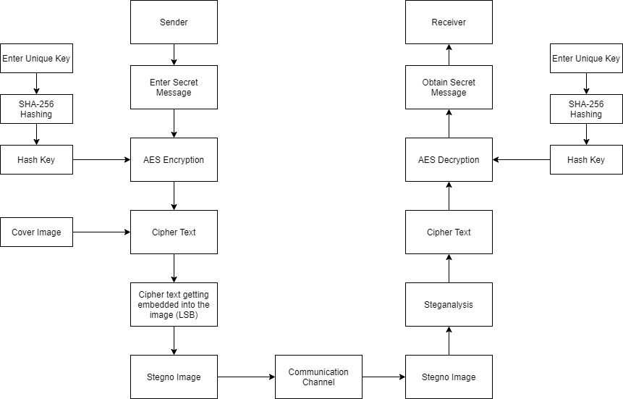

Figure 4. Detailed Architecture of Proposed Method

1. **EXPERIMENTAL RESULT**

The proposed method has been implemented in order invent a secure and impermeable system. And to do an analysis of the result in order to find out whether the proposed system is working accordingly as per design in consideration of requirements or not.

Table 5: Original and Stegno images

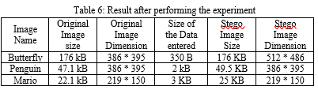

The above table 5 depicts that no change can be seen or persistent to human naked eyes and we cannot find out the difference between both the images i.e. original and stego image. So, by this confidentiality and covertness of   
  
  
the crucial data remains stagnant. Now, if we move forward to table 6 it depicts that no change in the dimension of the image is seen no matter how much amount of data been input into the image. Apparently, the data should always be less than the capacity of the image to hold it. The major difference is that if the data i.e. embedded in the original image comprises less than 1 KB then we cannot see the difference in the size of the image. Otherwise, the size of the image gets slightly increase as per the size of the data.

I have used python (Programming language) in order to implement the algorithm and to create a data securing system. And the libraries which I have used are:-

1. **pycryptodome** in order to perform AES (Advance Encryption Standard) encryption and decryption.
2. **Stegano** in order to implement image steganography via LSB (Least Significant Bit).
3. **Hashlib** in order to perform hashing via SHA-256 (Secure Hashing Algorithm).

The screenshot of the Proposed working system

1. Encoding

1. Decoding

1. Wrong Password

The above screenshot depicts that the working of the proposed system is efficient and accomplish the task and functionally robust. If the key is wrong the data cannot be extracted from it, even if the 1st layer of protection is been breached by any technique and the hacker identifies the image contains data. Then also the data is armored with other layer of protection and it cannot extract data from it as it is still being protected from cryptographic technique. The proposed system is robust and if a hacker tries to extract the data from the image, it is shielded with hashing, encryption, and image steganography. In which each technique is impermeable and combination of all the three make it extremely secure. Hence, the proposed method manifest to provide robustly and secure image steganography as well as a secure and inoculative system against data hacking.

1. **CODE**
2. KeyCreation and Hide Method

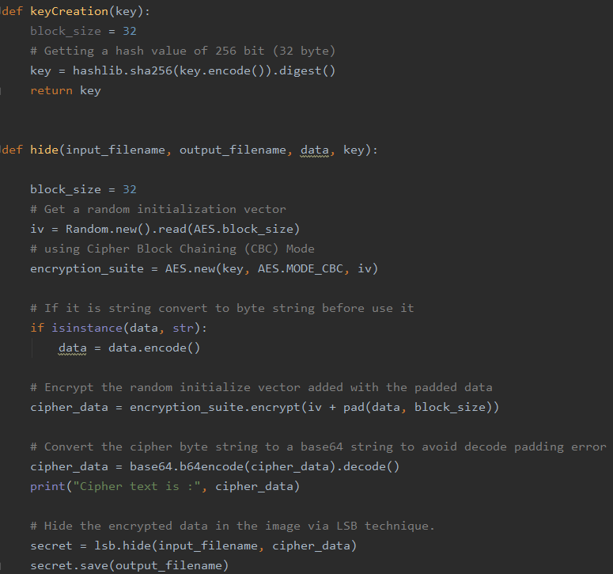

1. Retrieve Method

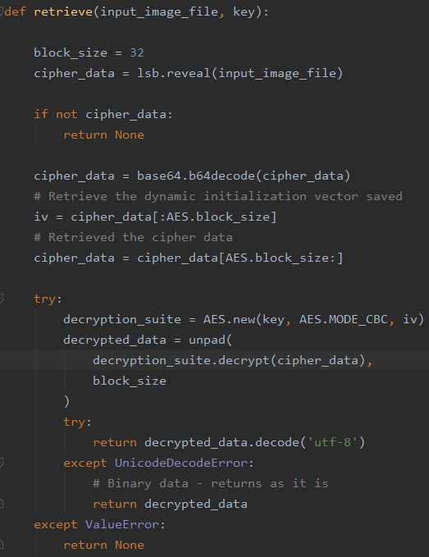

1. **RESULT ANALYSIS**

By the combination of all three methods we created a robust system. The data gets encrypted by most secure cryptographic technique and then this data gets hided inside an image which leaves no mark of any classified information communication taking place. As the visual aids remains intact. Its results can be seen in table 5 & table 6. And the weak point that a hacker targets is also been procured which is a key by hashing technique and the utilization of that key is done in encrypting and decrypting the data. Which adds on the layer of protection to the classified data. So, our goal gets achieved firstly no sign of secret communication and for safety adding more security layers on it. The data as encrypted and embedded in the image at the time of retrieval it gives the same data while using authentic secure key.

1. **CONCLUSION**

The proposed system accomplishes the task of securing the classified information. Primarily no one gets a hint that some crucial data is being exchanged, and secondly it also gets shielded by using cryptography. The proposed system successfully hides the data using image steganography via LSB and surplus the protection of data using cryptographic technique AES-256 as well as the weak point which a hacker could target that is key, it has also been armored via the use of hashing technique SHA 256. And an impenetrable system is created. The experimentation performed assures the concreteness of the proposed system. The results acquire a camouflaged image, a non-noticeable distortion making it almost non-viable to attract the consciousness of attackers and even after getting it tranced without an authentic key no one was able to access that information. Hence, proposed system proves to be a highly secure system in the terms of securing classified information and exchanging it and it also seals up with no vulnerability in it.

1. **REFRENCES**
2. Provos, Niels, and Peter Honeyman. "Hide and seek: An introduction to steganography." IEEE security & privacy 99.3 (2003): 32-44.
3. Henri Gilbert and Helena Handschuh, “Security Analysis of SHA-256 and Sisters*”, 2003.
4. Selent, Douglas. "Advanced encryption standard." Rivier Academic Journal 6.2, ISSN (Online): 2319-7064 Index Copernicus  
   Value (2015): 78.96 ,(2010): 1-14.
5. United States [National Security Agency](https://en.wikipedia.org/wiki/National_Security_Agency) (NSA), U.S. Department of Commerce, National Institute of Standards and Technology (NIST), Information Technology Laboratory (ITL), “Secure Hash Signature Standard (SHS) (FIPS PUB 180-2)”, National Institute of Standards and Technology (NIST), 2001 : 9-22.
6. Charles G. Boncelet, Jr., Newark, DE (US); Lisa M. Marvel, Churchville, MD (US); Charles T. Retter, Belcamp, MD (US). “Spread spectrum and image steganography”, 2003.
7. Po-Yueh Chen* and Hung-Ju Lin, “A DWT based approach for image steganography”, DOI:[10.6703/IJASE.2006. 4(3).275](https://doi.org/10.6703/IJASE.2006.4%283%29.275), 2006.
8. Domenico Bloisi and Luca Iocchi, “Image based steganography and cryptography”, 2007.
9. Ali Al-Ataby and Fawzi Al-Naima, “A modified high capacity image steganography technique based on wavelet transform”, Vol. 7, No. 4, October 2010.
10. Shailender Gupta, Ankur Goyal, Bharat Bhushan, “Information hiding using least significant bit steganography and cryptography”, DOI: [10.5815/ijmecs.2012.06.04](https://www.researchgate.net/deref/http%3A%2F%2Fdx.doi.org%2F10.5815%2Fijmecs.2012.06.04), 2012.
11. Saiful Islam*, Mangat R Modi and Phalguni Gupta “Edge-based image steganography”, DOI: 10.1186/1687-417X-2014-8, 2014.
12. *Khan Muhammad, Jamil Ahmad, Haleem Farman, Muhammad Zubair, “A novel image steganographic approach for hiding text in color images using HSI color model”, DOI: [10.5829/idosi.mejsr.2014.22.05.21946](https://www.researchgate.net/deref/http%3A%2F%2Fdx.doi.org%2F10.5829%2Fidosi.mejsr.2014.22.05.21946),2015.
13. Khan Muhammad, Jamil Ahmad, Muhammad Sajjad, Muhammad Zubair, “Secure image steganography using cryptography and image transposition”, October2015.
14. Mwaffaq Abu-Alhaija “Crypto-Steganographic LSB-based System for AES-Encrypted Data”, *(IJACSA)* International Journal of Advanced Computer Science and Applications, Vol. 10, No. 10, 2019.
15. M. Rahul, M. Malathi, N. Satish Kumar, R. Thamaraiselvan, “Enhanced Image Steganography Using AES & SPIHT Compression”, International Conference on Innovations in Information Embedded and Communication Systems (ICIIECS), March 2017, DOI: 10.1109/ICIIECS.2017.8276029.

**Authors Profile**

Mr. Yash Kumar Shukla is a bachelor’s in computer application from Integral University. He is currently pursuing master’s in computer application in JSS Academy of Technical Education, a prestigious institute affiliated to Abdul Kalam technical University, Lucknow, UP. As a final year student, he is also associated with a Artificial Intelligence and software based service/product company for his industrial internship and experience and is working as a developer intern.